A

Mini Project Report

on

**JOB4U**

Submitted to



**BHILAI INSTITUTE OF TECHNOLOGY, DURG**

An Autonomous Institute

Affiliated to

**Chhattisgarh Swami Vivekanand Technical University, Bhilai (C.G.)**

***In partial fulfillment of the requirements for the award of***

**Bachelor of Technology**

in

**Computer Science and Engineering, Semester**

Bhumika Sahu University Roll No.: 300102224111

Khushi Gedam University Roll No.: 300102221098

Sneha Bharti University Roll No.: 300102221109

Adyali Agrawal University Roll No.: 300102221112

**Under the Guidance of**

**PROF. MONIKA VERMA**

**Session 2022-2023**

**DECLARATION BY THE CANDIDATES**

We the undersigned solemnly declare that the report of the project work entitled Job4u, is based on my own work carried out during the course of our study under the supervision of Dr. (Mrs.)Sunita Soni.

We assert that the statements made and conclusions drawn are an outcome of the project work. We further declare that to the best of our knowledge and belief that the report does not contain any part of any work which has been submitted for the award of any other degree/diploma/certificate in this University/ any other University of India or any other country.

(Signature of the Candidate) (Signature of the Candidate)

Name: Bhumika Sahu Name: Khushi Gedam

Roll No.: 300102224111 Roll No.: 300102221098

Enrollment No.: CB4311 Enrollment No.: CB4289

Semester: 3rd  Semester: 3rd

(Signature of the Candidate) (Signature of the Candidate)

Name: Sneha Bharti Name: Adyali Agrawal

Roll No.: 300102221109 Roll No.: 300102221112

Enrollment No.: CB4300 Enrollment No.: CB4299

Semester: 3rd  Semester: 3rd

**CERTIFICATE**

This is to certify that the report of the project submitted is an outcome of the project work entitled Job4u is carried out under our guidance and supervision for the award of Degree in Bachelor of Engineering in Computer Science from Chhattisgarh Swami Vivekanand Technical University, Bhilai (C.G).

To the best of my knowledge the report

i) Embodies the work of the candidate himself / herself,

ii) Has duly been completed,

iii) Fulfills the requirement of the Ordinance relating to the BE degree of the University,

iv) Is up to the desired standard for the purpose of which is submitted.

Signature of Coordinator

Prof Monika Verma

Computer Sc. & Engg.

The Project work as mentioned above is hereby being recommended and forwarded for examination and evaluation.

Dr. (Mrs.) Sunita Soni

Head of the Department

Computer Sc. & Engg

**CERTIFICATE BY THE EXAMINERS**

This is to Certify that the project the entitled

“JOB4U”

Submitted by

|  |  |  |
| --- | --- | --- |
| Name: Bhumika Sahu | Enrollment No.: CB4311 | Roll No.: 300102224111 |
| Name: Khushi Gedam | Enrollment No.: CB4289 | Roll No.: 300102221098 |
| Name: Sneha Bharti | Enrollment No.: CB4300 | Roll No.: 300102221109 |
| Name: Adyali Agrawal | Enrollment No.: CB4299 | Roll No.: 300102221112 |

Have been examined by the undersigned as a part of the examination for the award of Bachelor of Engineering degree in Computer Science and Engineering from Chhattisgarh Swami Vivekanand Technical University, Bhilai (C.G).

|  |  |
| --- | --- |
| Internal examiner | External examiner |
| Date: | Date: |

**ACKNOWLEDGEMENT**

We have great pleasure in the submission of this project report entitled JOB4U in partial fulfillment the degree of Bachelor of Engineering (CSE). While submitting this Project report, we take this opportunity to thank those directly or indirectly related to project work.

We would like to express sincere thanks and gratitude to Dr. Mohan Kumar Gupta, Principal of the Institution, Dr. (Mrs.) Sunita Soni, Head of the Department Computer Science & Engineering for their encouragement and cordial support.

While Submission of the project, we would also like to thank Prof. Mrs. Monika Verma, Project Coordinator, faculty and all the staff of department of Computer Science & Engineering, Bhilai Institute of Technology, Durg for their continuous help and guidance throughout the course of project.

Also, we would extend our gratitude to our parents, family members, friends and all others who have helped us directly or indirectly in the successful completion of the project work.

|  |  |  |
| --- | --- | --- |
| Name: Bhumika Sahu | Enrollment No.: CB4311 | Roll No.: 300102224111 |
| Name: Khushi Gedam | Enrollment No.: CB4289 | Roll No.: 300102221098 |
| Name: Sneha Bharti | Enrollment No.: CB4300 | Roll No.: 300102221109 |
| Name: Adyali Agrawal | Enrollment No.: CB4299 | Roll No.: 300102221112 |

##### ABSTRACT

One of the biggest apocalyptic cries in the global economy today is the loss or obsolescence of existing jobs due to automation and rapid changes in technology.

India’s unemployment rate for those who are 20 years of age or older and live in urban areas dropped from 9.8% to 7.2%, indicating a sustained recovery from the coronavirus pandemic that had left millions of people without jobs.

Engineering is one of the most popular professions and career options among the youth in India. As a matter of fact more than 15 lakh students get graduated as engineers in India every year which is largest in the world but the twist and sad thing in the story is that more than 80% of the engineers do not get any employment due to lack of technical skills and only 3% of engineers get good quality job related to the sector.

As a solution Our New JOB4U website is here! Making it Easier than Ever to Stay In Touch with important and genuine Information that you Need to be Successful

Now you can quickly find jobs and available interships you're looking for in JOB4U,as here you will get your desired jobs with different sections. For example, you can search jobs according to your branch in the engineering field.

**CONTENTS**

|  |  |
| --- | --- |
| **TOPICS** | **PG.NO** |
| 1. INTRODUCTION    1. PROJECT DESCRIPTION    2. METHOODOGY |  |
| 1. SOFTWARE REQUIREMENTS\   2.1 HTML  2.2 CSS  2.3 JAVASCRIPT  2.4 WEB SCRAPPING |  |
| 3. IMPLEMENTATION  3.1 FRONTEND  3.1.1 THE ICON BAR  3.1.2 THE LOGO BAR  3.1.3 THE POSTER  3.1.4 JOBS BASED ON BRANCHES  3.1.5 THE FOOTER  3.1.6 THE COPYRIGHT  3.2 BACKEND |  |
| 4. CONCLUSION |  |
| 5. FUTURE SCOPE  5.1 SCOPE  5.2 FUTURE APPLICATION AND IMPLEMENTAION |  |

**REFRENCRES OF FIG**

|  |  |  |
| --- | --- | --- |
| **FIG NUMBER** | **DESCRIPTION** | **PAGE NUMBER** |
| 3.1.1 | The icon Bar |  |
| 3.1.2 | The Logo Bar |  |
| 3.1.3 | The Poster |  |
| 4 |  |  |
| 5 |  |  |
| 6 |  |  |
| 7 |  |  |
| 8 |  |  |
| 9 |  |  |
| 10 |  |  |
| 11 |  |  |

**1.INTRODUCTION**

A million of engineering students are struggling to get placed is an extremely challenging in market

Somewhere between a fifth to a third of the million students graduating out of engineering colleges run the risk of being unemployed.

B.Tech (Bachelor of Technology) is one of the most preferred undergraduate degree courses among students from the Science stream post-school. The 4-year engineering course is offered by many colleges across India. Once you have completed engineering, what next? What to do after B.Tech? What are the available jobs after B.tech? These questions are faced by many engineering students in the fourth year of B.Tech.

There are many routes you can take after completing your B.Tech. However, with the huge number of career options available, it is natural that you may feel confused about which one to select. Frustrated engineers are taking jobs for which they are overqualified and, therefore, underpaid. There are so many new jobs being created every year. The number of new engineers is far higher. Most Indian engineering colleges provide no or very bad internship opportunities. Most engineers have no clue what the industry actually is like..

The student fail to understand the importance of trustworthy online websites which are providing jobs and relying on platforms like facebook and instaram for job search which is a major mistake.

To help you decide where to go for the jobs according to your interest, we have prepared a website which will increase your limited options for jobs.

Our project is all about providing the best website for engineering students to search jobs and Interships or to know about the current government vacancies available. People don’t have to waste their time by going through all the jobs for each branch.

We have divide our website according to the interest of the students and according to their branches.

* 1. **PROJECT DESCRIPTION**

The 'JOBS4U' website is built to overcome the problem of the tiring and time consuming process of job search.

* The job searchers will be able to find employment in their fields.
* Our Website is an easy-to-use tool that shows information without being overly complicated.
* The website will make finding a job quite effective.
* Visitors to our websites will receive an updated jobs list.
* Users will receive assistance in selecting a specific career path.

**1.2 METHODOLOGY**

**2. SOFTWARE REQUIREMENTS**

**2.1.HTML**

* To understand "HTML" from front to back, let's look at each word that makes up the abbreviation:
* **Hypertext**: text (often with embeds such as images, too) that is organized in order to connect related items.
* **Markup**: a style guide for typesetting anything to be printed in hardcopy or soft copy format.
* **Language**: a language that a computer system understands and uses to interpret commands.
* HTML determines the structure of web pages. This structure alone is not enough to make a web page look good and interactive. So you'll use assisted technologies such as CSS and JavaScript to make your HTML beautiful and add interactivity, respectively.

**2.2.CSS**

* CSS stands for Cascading Style Sheets.
* CSS describes how HTML elements are to be displayed on screen, paper, or in other media.
* CSS saves a lot of work. It can control the layout of multiple web pages all at once External stylesheets are stored in CSS files.

**2.3.JAVASCRIPT**

* JavaScript is a scripting language that enables you to create dynamically updating content, control multimedia, animate images, and pretty much everything else. (Okay, not everything, but it is amazing what you can achieve with a few lines of JavaScript code.

**2.4. WEB SCRAPPING**

* Web scraping refers to the extraction of data from a website. This information is collected and then exported into a format that is more useful for the user.

**3.IMPLEMENTATION**

**3.1.FRONTEND**

**3.1.1 The icon Bar:** Icon is a small graphical representation of a program or file. When we click an icon, the associated file or program will be opened. For example, if we were to click on the Facebook icon, it would open Facebook.



Fig.1

**3.1.2 The Logo Bar:** A logo is a symbol made up of text and images that identifies a business.



Fig.2

**3.1.3 The Poster:** Typically, Posters include both textual and graphic elements,although a poster may be either wholly graphical or wholly text. Posters are designed to be both eye-catching and informative.



Fig.3

**3.1.4 Jobs Based on Branches:** Here you will get jobs according to your branches.

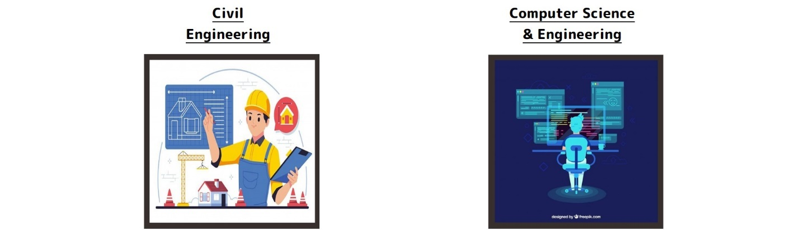

Fig.4 Fig.5

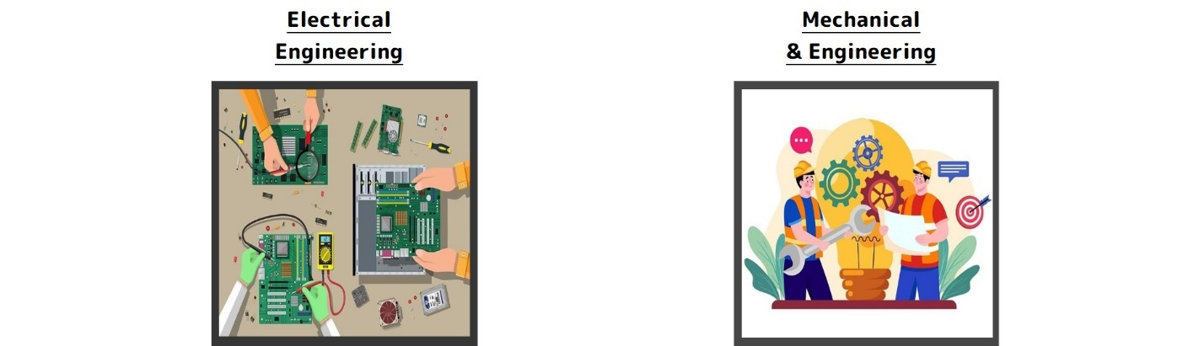

Fig.6 Fig.7

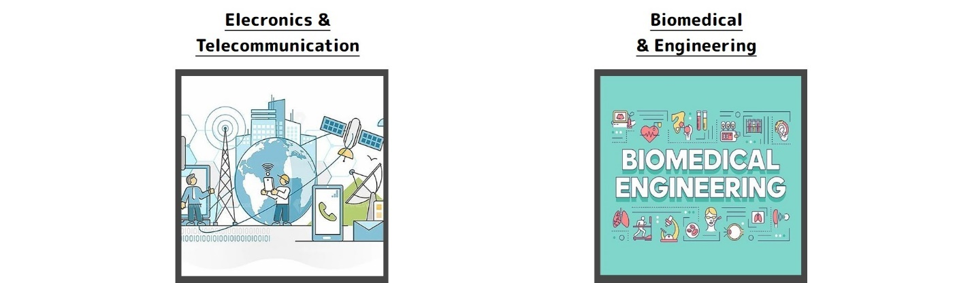

Fig.8 Fig.9

**3.1.5 The Footer:** A Website’s footer is an area located at the bottom of every page on a website, below the main body content. The term “footer” comes from the print world, in which the “footer” is a consistent design element that is seen across all pages of a document.

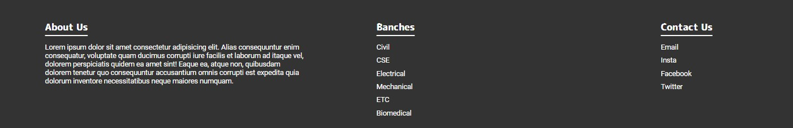

Fig.10

**3.1.6 The Copyright:** Copyright refers to the legal right of the owner pf intellectual property. In simpler terms, copyright is right to copy . This means that the originl creators of products and anyone they give authorization to are the only ones with the exclusive right to reproduce the work.



Fig.11

**4.CONCLUSION**

Working on this fascinating and difficult project has been a real pleasure for us. An effective way for job seekers to look online for information on open positions is through a job portal. This portal's primary objective is to attempt to develop graduates who are appropriate for the market.

The greater scope of job searching makes it quicker and simpler to discover prospects. Today's changing business environment and expanding employment chances have prompted more people to look for better careers and employers to look for better potentials.

**5. FUTURE SCOPE**

Additionally, we may add extra features to improve its effectiveness or efficiency and make it more APPEALING

**5.1 SCOPE**

* Data or File uploader
* Creating a resume
* Individual or Personal Profile

**5.3 FUTURE APPLICATION AND IMPLEMENTATION**

* In situations where clients already have a completed resume, the ability to upload a resume file is helpful. In that situation, customers don't need to spend more time filling out the questionnaire to create their resume; they can just upload the document.
* The users are required to complete a questionnaire about their job, their education, their talents, their prior experience, their desired income, their location, and their certification.
* All the resources and data a person could require to begin a job search are available in the personal profiles on a job search website.

Such websites or customer profiles feature job filters, suggestions, and opportunities to:

research salaries

follow businesses

viewing featured content

gain additional useful information

**5. FUTURE SCOPE**

Additionally, we may add extra features to improve its effectiveness or efficiency and make it more APPEALING

**5.1 SCOPE**

* Data or File uploader
* Creating a resume
* Individual or Personal Profile

**5.3 FUTURE APPLICATION AND IMPLEMENTATION**

* In situations where clients already have a completed resume, the ability to upload a resume file is helpful. In that situation, customers don't need to spend more time filling out the questionnaire to create their resume; they can just upload the document.
* The users are required to complete a questionnaire about their job, their education, their talents, their prior experience, their desired income, their location, and their certification.
* All the resources and data a person could require to begin a job search are available in the personal profiles on a job search website.

Such websites or customer profiles feature job filters, suggestions, and opportunities to:

research salaries

follow businesses

viewing featured content

gain additional useful information